EX 1: Study Planner Application
Aim
To develop a simple cloud-based Study Planner application that helps users organize their study tasks, set deadlines, and track progress using a SaaS platform.
Algorithm
- Start
- Create a study planner form
- Enter task details (subject, task, date, status)
- Store the data in cloud database
- Display tasks in a list format
- Allow user to update task status (Pending/Completed)
- Repeat for multiple tasks
- Stop
Procedure
- Open Zoho Creator
- Create a new application named Study Planner
- Create a form called Study_Tasks
- Add the following fields:
  - Task_ID (Auto Number)
  - Subject (Single Line)
  - Task_Description (Multi Line)
  - Due_Date (Date)
  - Status (Dropdown: Pending, Completed)
- Save the form
- Create a report to view tasks
- Enter sample data and test the application
- Deploy the application to cloud

Output
- User can add study tasks
- Tasks are displayed in a structured list
- User can track due dates and completion status
- Data is stored and accessed through cloud
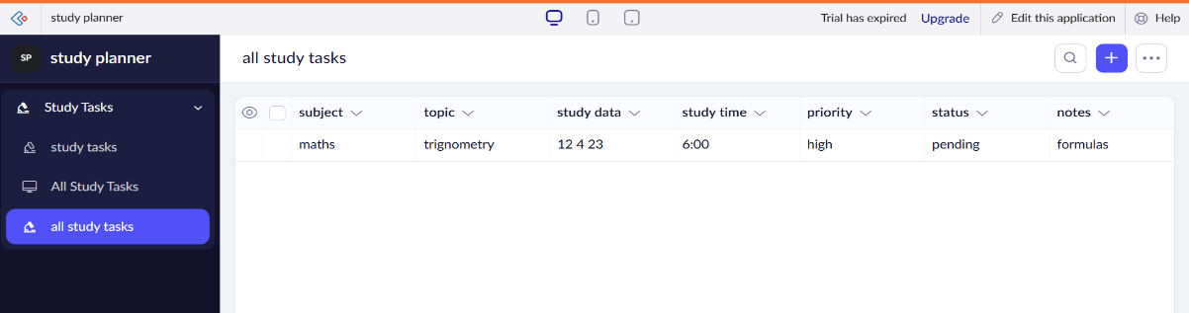

Result
A simple cloud-based Study Planner application was successfully developed using Zoho Creator. The system allows users to manage study tasks efficiently and demonstrates the SaaS model through online accessibility and centralized data storage.

